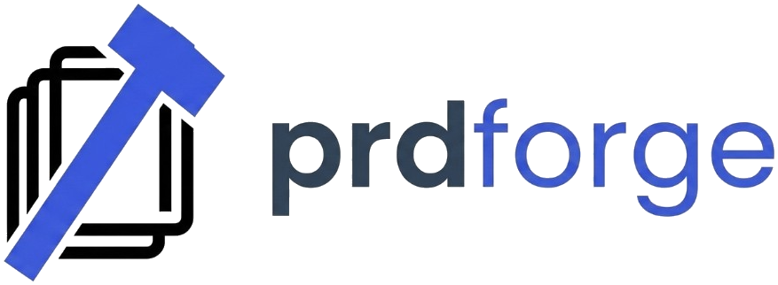

PRDForge — Master Execution Plan

Product Context
- Product: **PRDForge — AI-Powered PRD Design Platform**
- Status: Live at `prdforge.dev`
- Goal: Ship a usable v1 with strong onboarding, reliable core loop, and launch-ready growth system.

Plan A — Product Completion
**Objective:** Ship a usable v1 with clear onboarding + core PRD generation loop.

1. Freeze MVP scope (must-have only)
2. Finalize core flows:
- Auth
- Create project
- Generate PRD
- Edit/export/share
3. Add usage limits + robust error handling
4. Add analytics events (activation, retention, conversion)
5. Prepare release checklist

**Output Docs:**
- Product Scope v1
- Feature Completion Checklist
- Release Readiness Checklist

Plan B — QA + Testing
**Objective:** Prevent embarrassing launch issues.

1. Build test matrix:
- Browser/device
- Auth states
- API/network failure
- Edge prompts/long outputs
2. Run functional + smoke + regression tests
3. Add payment flow test cases (success/fail/refund/cancel)
4. Run UAT with severity labels (P0/P1/P2)
5. Produce Go/No-Go report

**Output Docs:**
- QA Test Plan
- Bug Tracker
- Go/No-Go Decision Sheet

Plan C — Payments Setup
**Objective:** Collect money reliably and compliantly.

1. Finalize pricing model (tiers, limits, trial)
2. Decide provider: Stripe/LemonSqueezy/Paddle
3. Setup:
- Products/prices
- Checkout
- Webhooks
- Subscription state sync
4. Design billing UX:
- Upgrade/downgrade/cancel
- Invoice history
5. Execute test mode + live mode switch checklist

**Output Docs:**
- Pricing & Packaging Doc
- Payments Integration Spec
- Live Switch Checklist

Plan D — Social + Content Engine
**Objective:** Build trust + inbound demand before/at launch.

1. Define brand positioning (who, problem, promise)
2. Set up channels: X + LinkedIn (+ optional TikTok/YouTube Shorts)
3. Build 30-day content calendar:
- Product demos
- Build-in-public updates
- PRD tips
- User pain-point posts
4. Refine landing page copy for conversion
5. Build prelaunch waitlist + CTA flow

**Output Docs:**
- Messaging Bible
- Social Content Calendar
- Launch Content Pack

Plan E — Ads Launch Plan
**Objective:** Validate paid acquisition with controlled spend.

1. Channel test stack: Meta + X + Google Search
2. Creative set:
- 5 hooks
- 3 creatives per hook
- 2 landing variants
3. Budget:
- 7-day small-budget test
- Kill/scale rules
4. KPI thresholds:
- CTR
- CPC
- Signup rate
- Trial→paid conversion
5. Daily optimization loop

**Output Docs:**
- Ads Test Matrix
- Budget + KPI Dashboard
- Scale/Stop Rules

Google Drive Project Structure
`Temi-Projects/PRDForge/`
- 01_Product/
- 02_Tech_QA/
- 03_Payments/
- 04_Marketing/
- 05_Ads/
- 06_Reports/
- 99_Archive/

Agent Ownership
- **Sheba:** Growth, monetization, pricing, channel strategy, ads economics
- **Fela:** Messaging, social assets, ad copy, creative concepts
- **Clawdia:** Orchestration, sequencing, risk gates, final delivery

Immediate Next 5 Actions
1. Lock MVP v1 scope
2. Choose payment provider + pricing draft
3. Build QA test matrix v1
4. Draft 14-day social launch calendar
5. Draft ads test plan with KPI thresholds

